**AWS EC2 Linux OS**

**By: Kevin Litchmore**

**Create EC2 Instance using Linux OS**

Step 1: Click “EC2” or “EC2 Dashboard”.

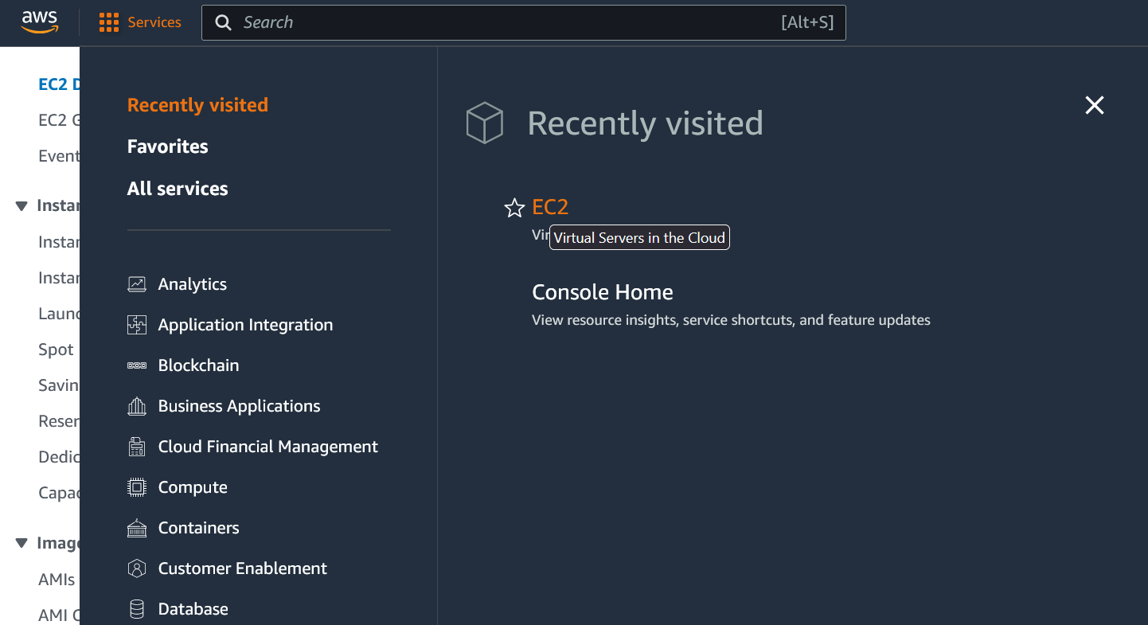

Step 2: Click “Launch instance”.

Step 3: Choose the Linux Amazon Machine Image (AMI).

Step 4: Generate a new key pair (Optionally give it a custom name).

Step 5: Network settings: Change allow SSH Traffic from “Anywhere” to “My IP”:

Step 6: Select Launch Instance:

Step 7: Select Instances:

Step 8: Wait until the check status says “2/2 check passed” (A page reload may be required if the checks are stuck at initializing):



Step 9: Right click your instance wait for the drop down menu to appear the click connect:

**Functionality Verification**

Step 1: Select SSH client then click on the boxes on the left under the example to copy it:

Step 2: Open power shell on your computer by typing into the search box:

Step 2: Type the following command :cd downloads

Step 3: Now paste the copied “example” from the AWS console into PowerShell (if it does not paste copy it again then paste in PowerShell):

Step 4: Type yes on the following screen:

When successfully the following text will display

Step 4 (Optionally): Create a simple text file to verify OS functionality:

